**Udagram: Your Own Instagram on AWS**

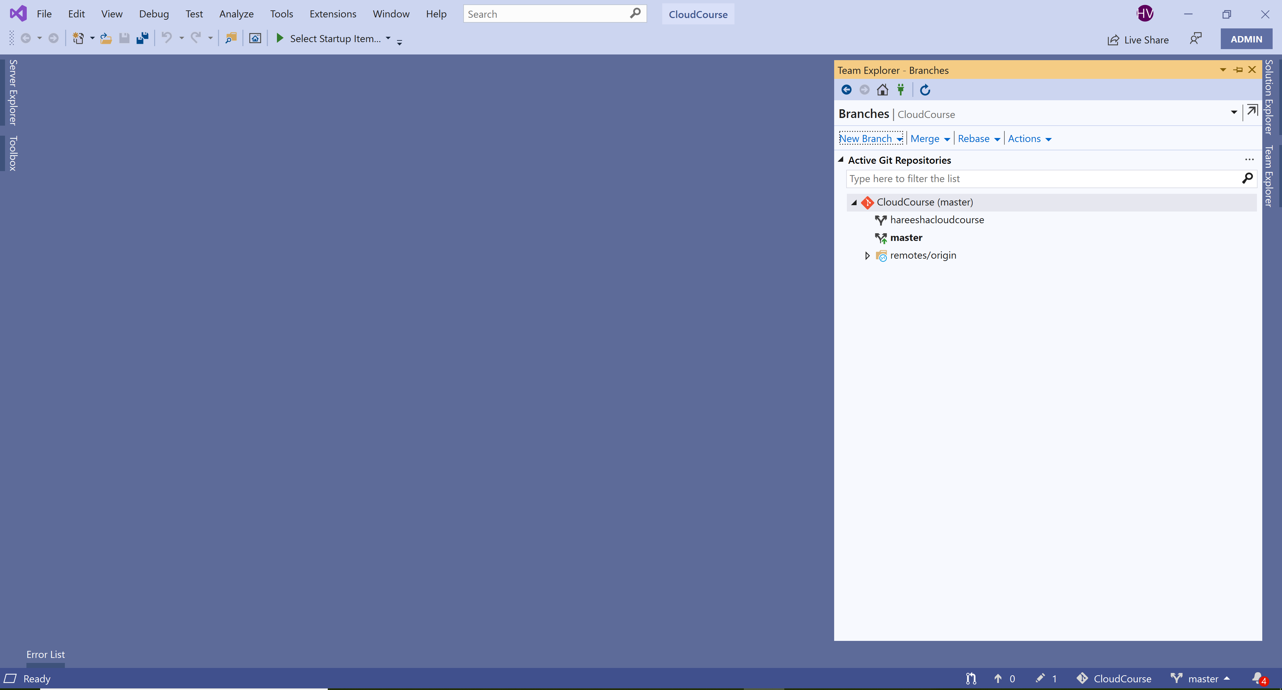

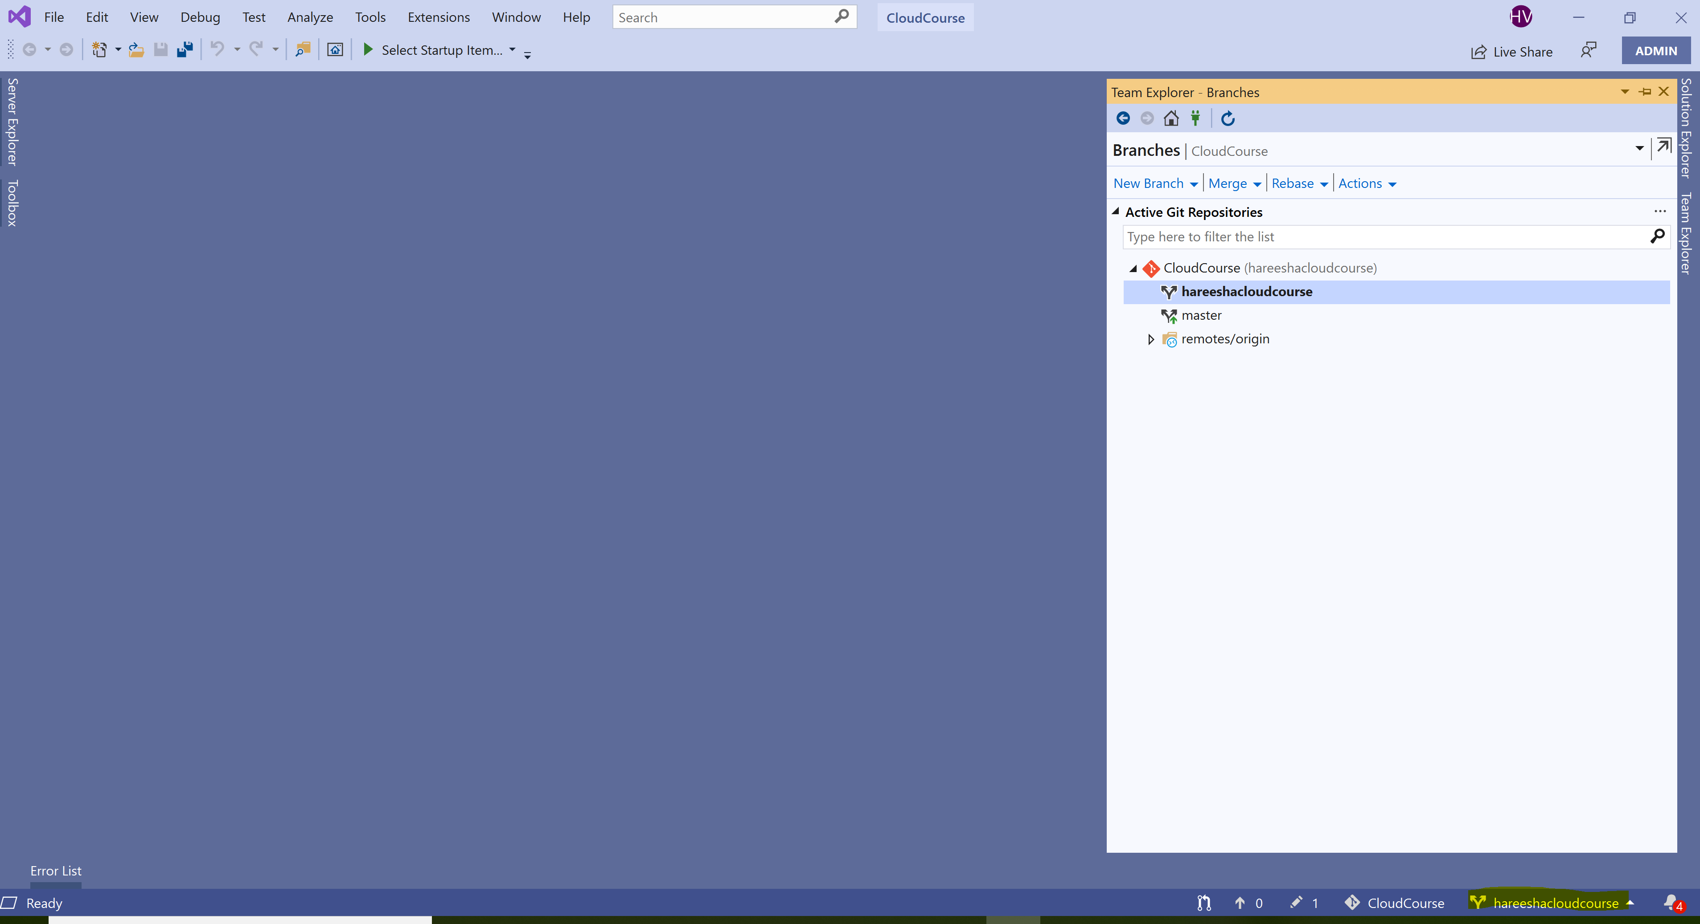

<https://github.com/hareeshavilluri/Cloud-Developer-Project2>

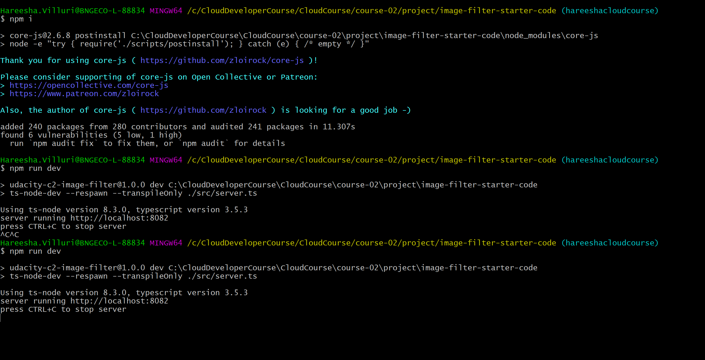

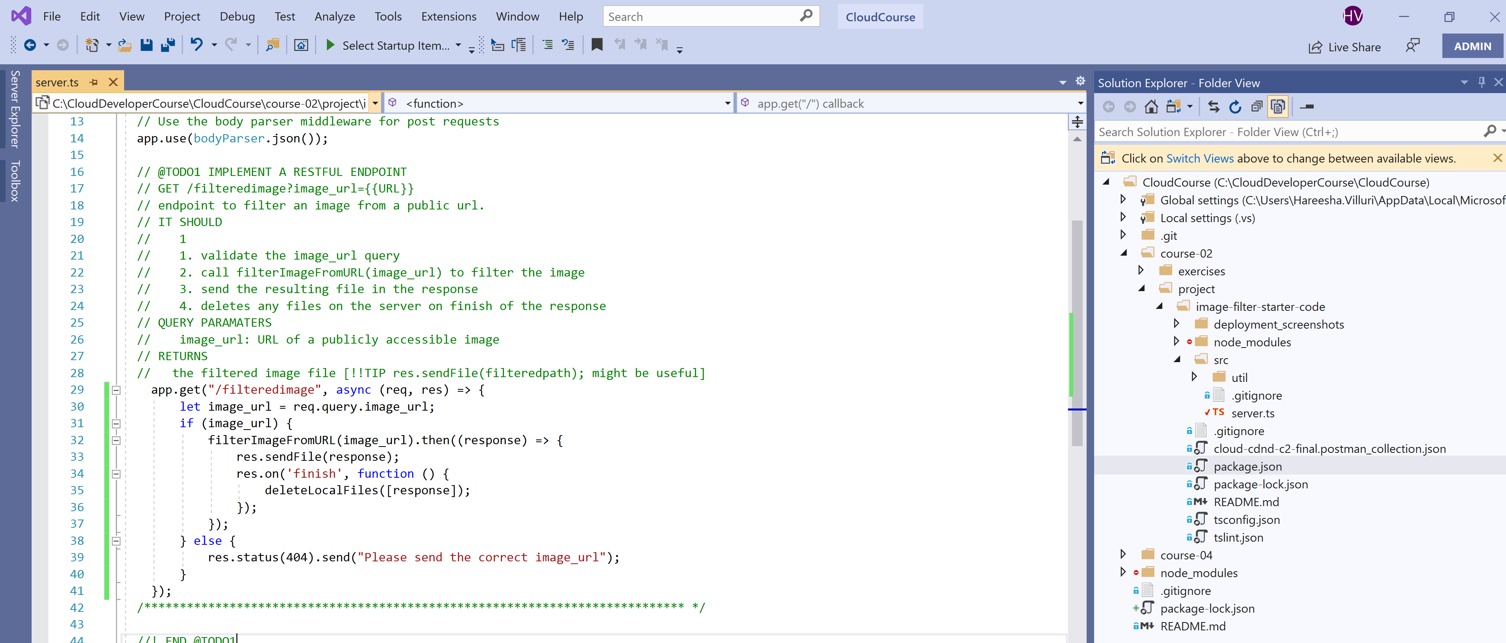

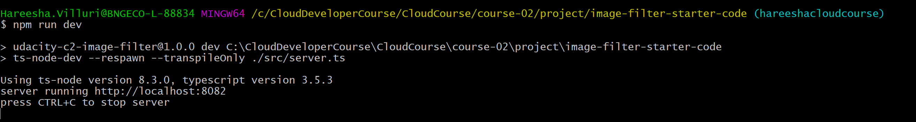

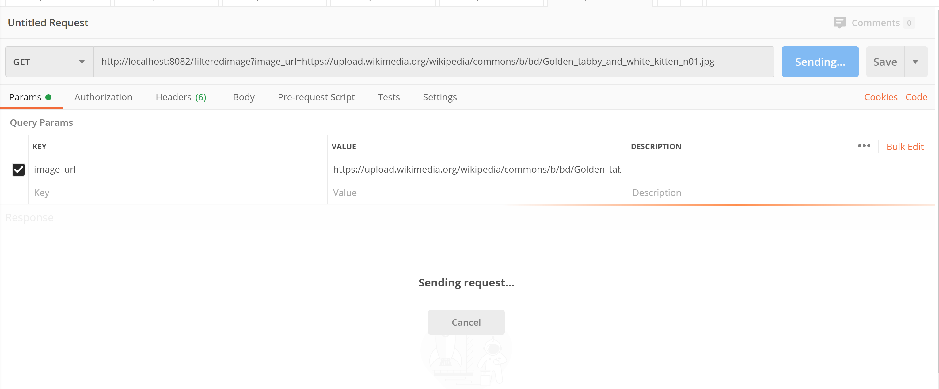

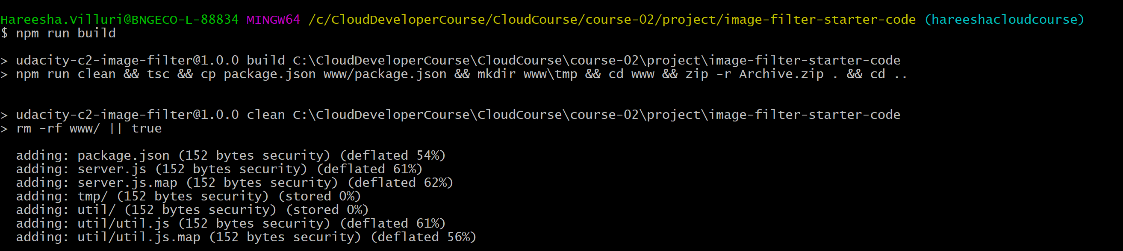

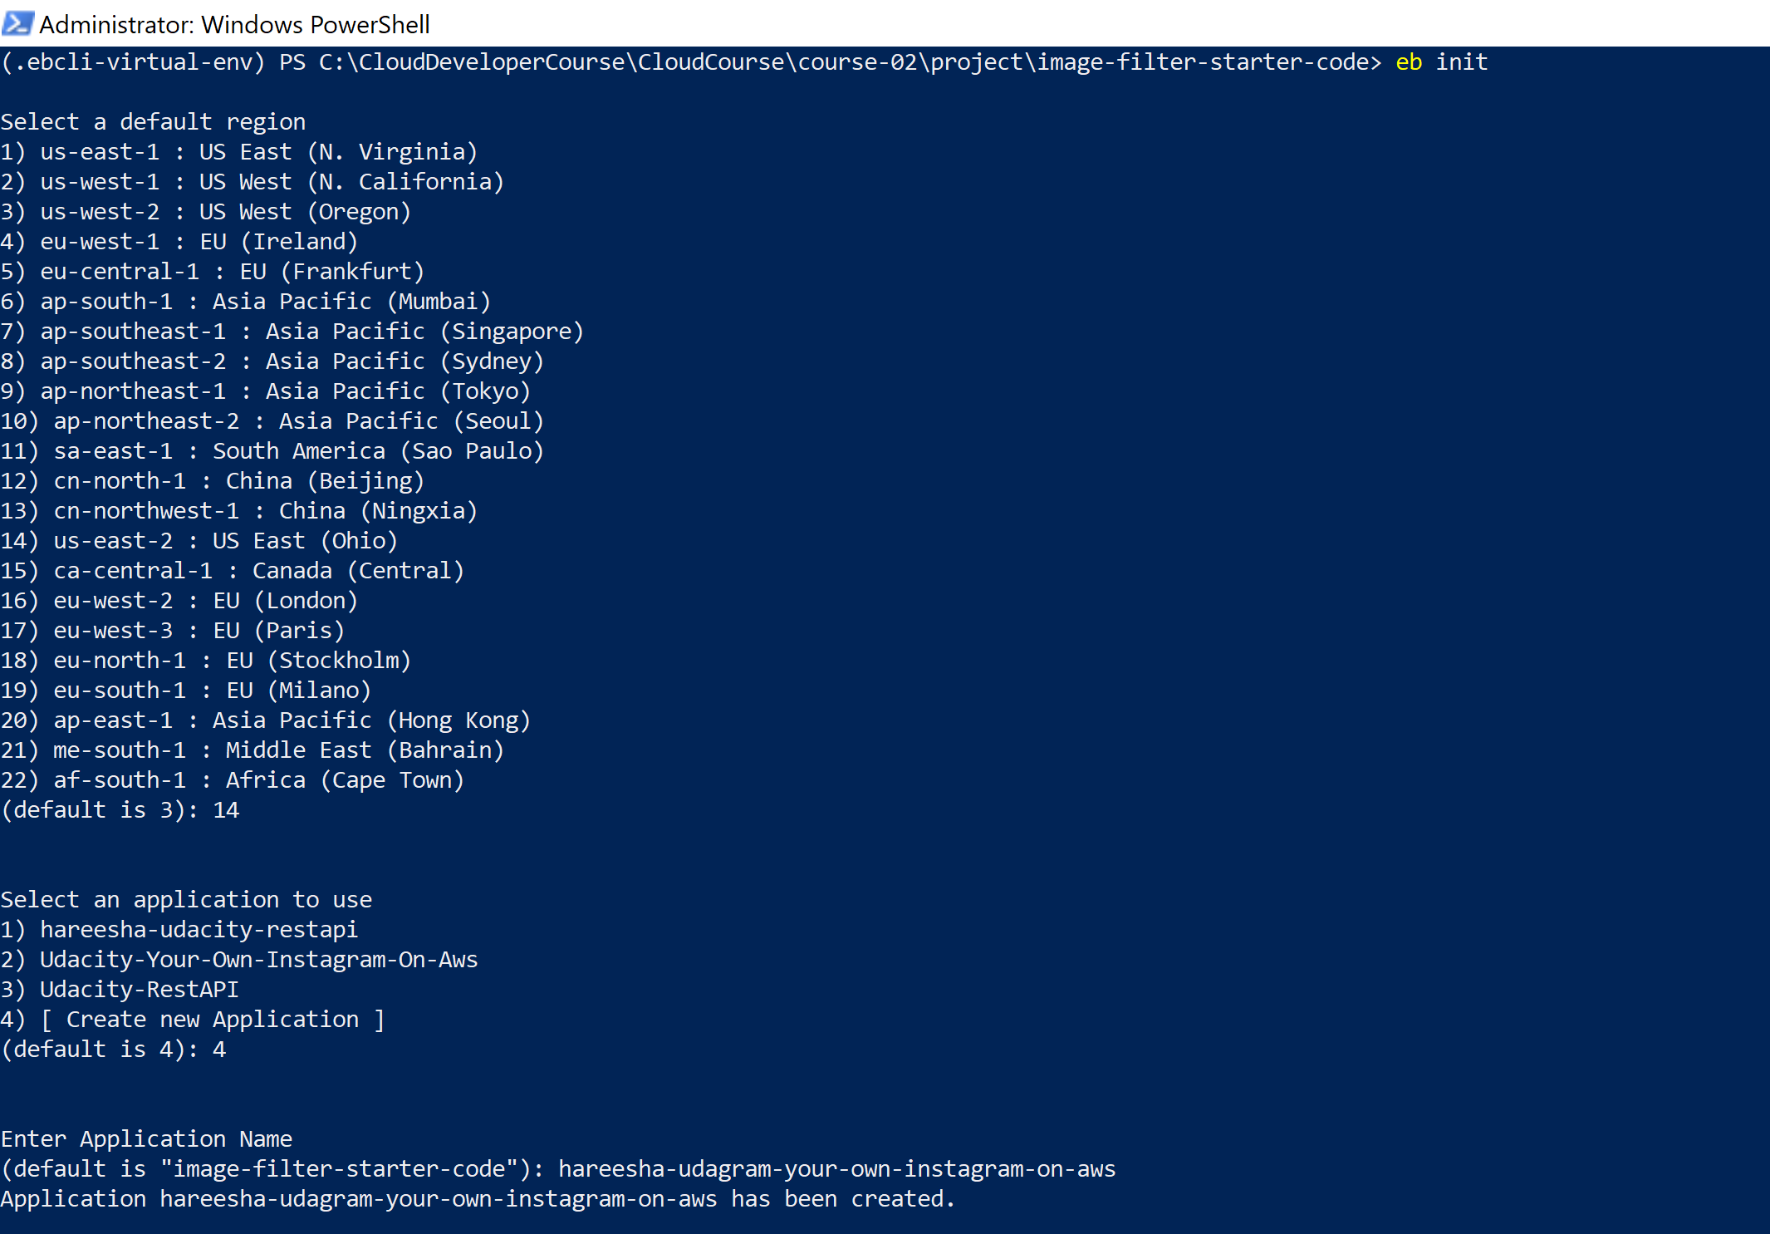

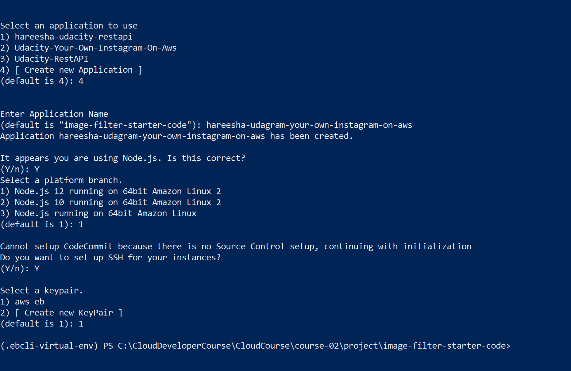

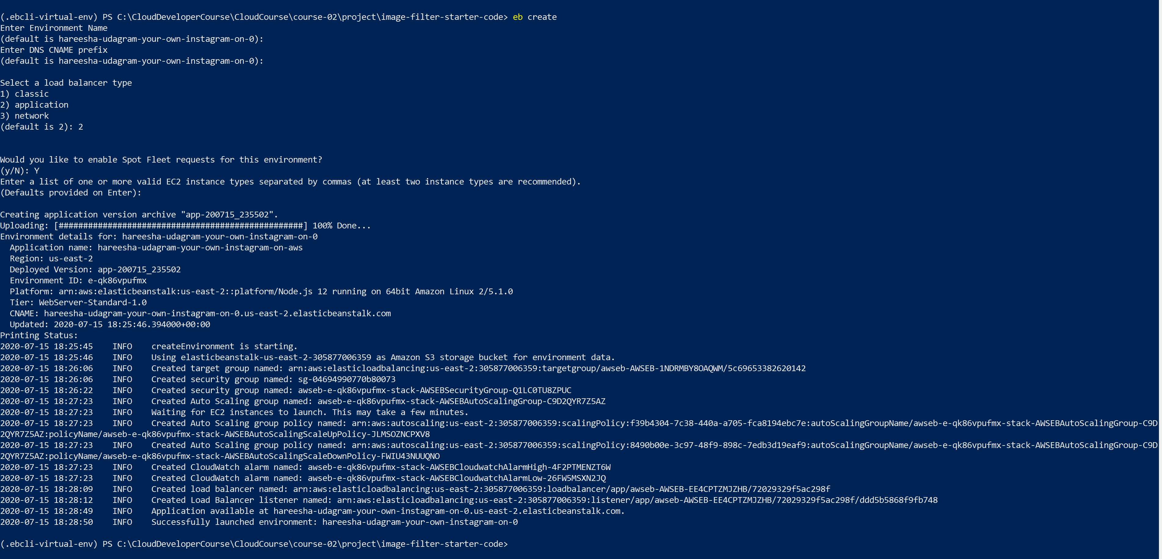



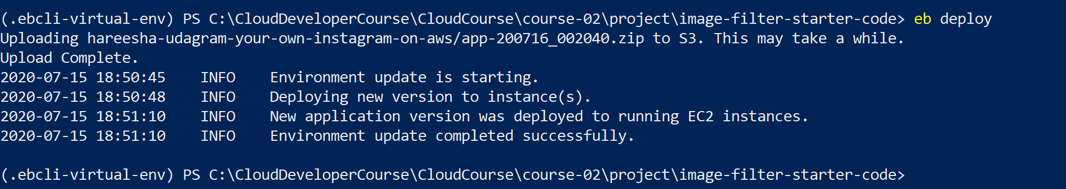

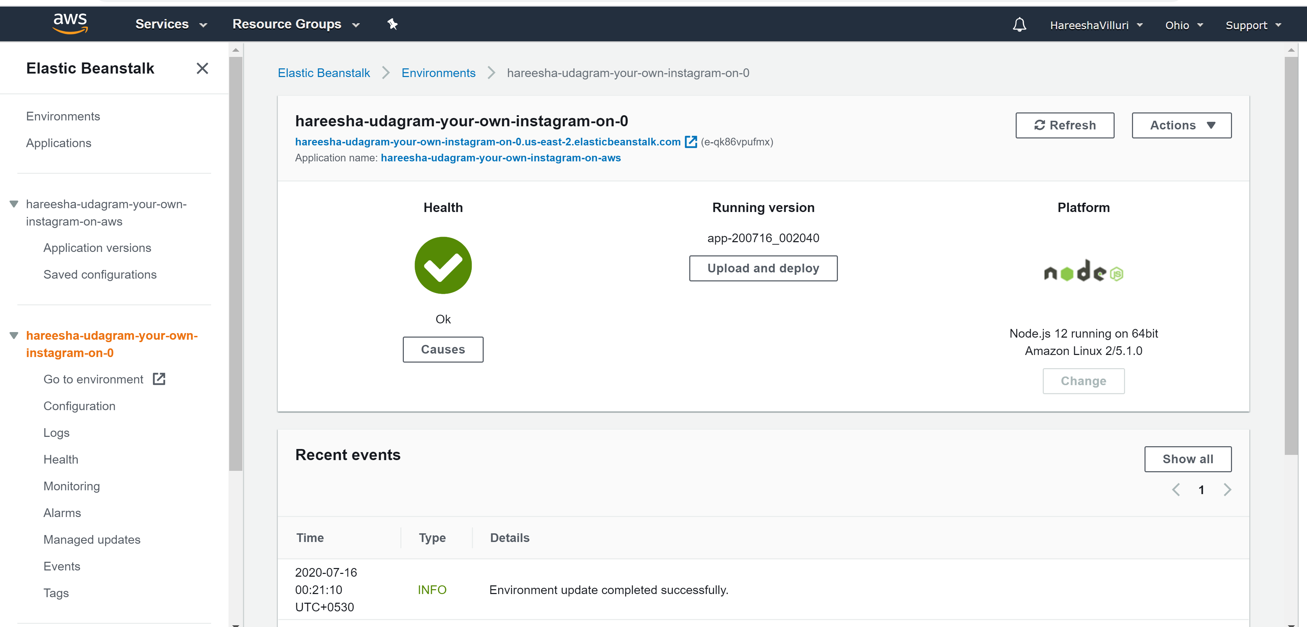

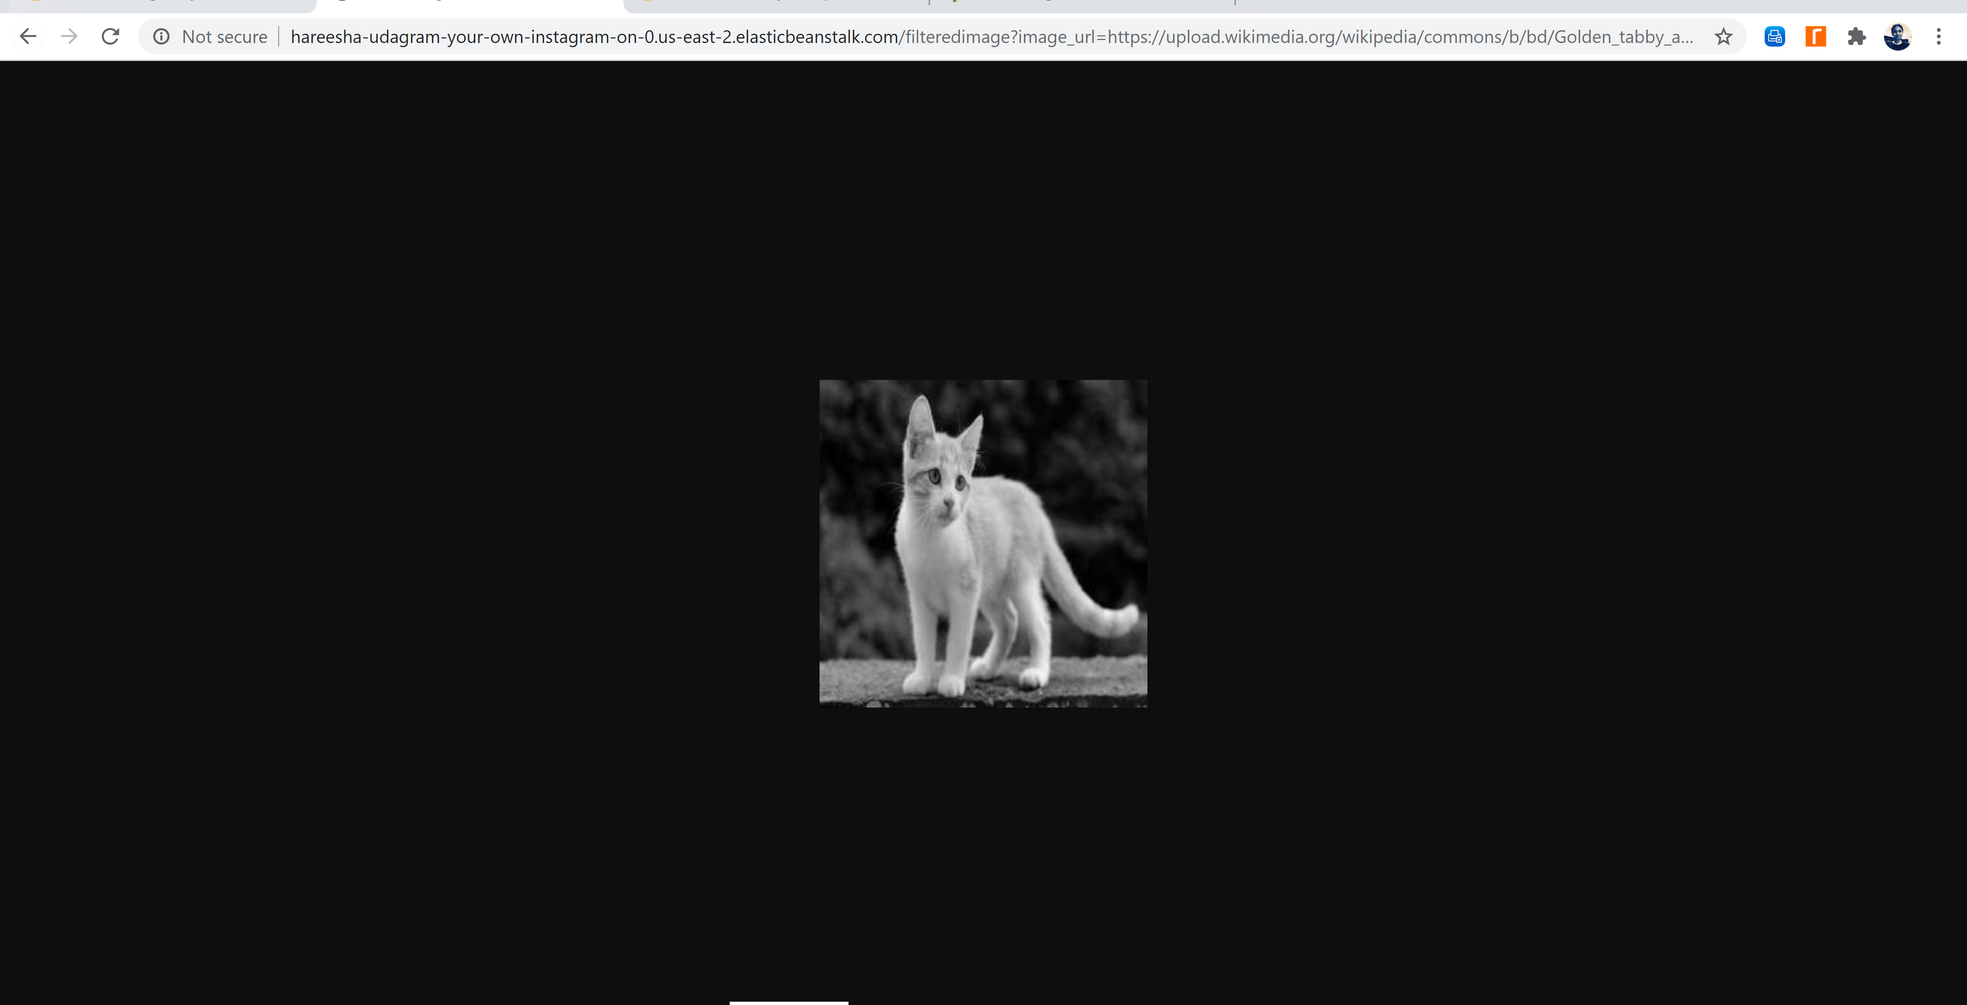

Path - <http://hareesha-udagram-your-own-instagram-on-0.us-east-2.elasticbeanstalk.com/filteredimage?image_url=https://upload.wikimedia.org/wikipedia/commons/b/bd/Golden_tabby_and_white_kitten_n01.jpg>